

Activity 1. [Calculate how many more years we can continue using this way of counting.]

The biggest number we can represent with long is 1111 1111 1111 1111 1111 1111 1111 1111 1111 1111 1111 1111 1111 1111 1111 1111 in binary, which are 292278994 translated into decimal. This means the maximum number of years we can represent is 292278994. Taking into account that we have started counting since 1-1-1970, which means that have passed 54 years until today, we can keep using this way of counting for 292278940 years.

Activity 2. [What does it mean that the time measured is 0?

From what size of problem (n) do we start to get reliable times]

It means that the measured time is lower than 50 milliseconds, which is not representative.

We start getting reliable times when measured times are equal or bigger than 50ms, in my case, it is with a size of n = 14000000

Activity 3. [What happens with the time if the problem size is multiplied by 2?

What happens with the time if the problem size is multiplied by a value k other than 2? (try it, for example, for k=3 and k=4 and check the times obtained)

From what we saw in Vector4.java measuring the times for sum, create the following three java

classes:

• Vector5.java to measure times for maximum.

• Vector6.java to measure times for matches1.

• Vector7.java to measure times for matches2.

Indicate the main features (processor and memory) of the computer where times have been

measured.

Once both tables are filled in, conclude whether the times obtained meet what was expected,

given the computational time complexity of the different operations.]

1- As we are in a linear complexity, times are also multiplied by 2

Base times:

SIZE=10 TIME=79 milliseconds SUM=-312 NTIMES=1000000

SIZE=50 TIME=218 milliseconds SUM=-218 NTIMES=1000000

SIZE=250 TIME=910 milliseconds SUM=-1610 NTIMES=1000000

SIZE=1250 TIME=4328 milliseconds SUM=771 NTIMES=1000000

Times multiplying the size by 2:

SIZE=10 TIME=155 milliseconds SUM=-199 NTIMES=2000000

SIZE=50 TIME=434 milliseconds SUM=409 NTIMES=2000000

SIZE=250 TIME=1795 milliseconds SUM=1149 NTIMES=2000000

SIZE=1250 TIME=8653 milliseconds SUM=-1519 NTIMES=2000000

2- As said before, times are multiplied by k

Times multiplying the size by 3:

SIZE=10 TIME=238 milliseconds SUM=4 NTIMES=3000000

SIZE=50 TIME=646 milliseconds SUM=-362 NTIMES=3000000

SIZE=250 TIME=2687 milliseconds SUM=-1135 NTIMES=3000000

SIZE=1250 TIME=12978 milliseconds SUM=2597 NTIMES=3000000

Times multiplying the size by 4:

SIZE=10 TIME=312 milliseconds SUM=50 NTIMES=4000000

SIZE=50 TIME=862 milliseconds SUM=-93 NTIMES=4000000

SIZE=250 TIME=3629 milliseconds SUM=830 NTIMES=4000000

SIZE=1250 TIME=17226 milliseconds SUM=-501 NTIMES=4000000

3-

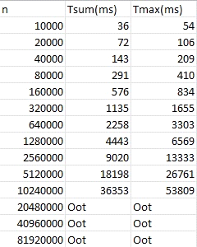 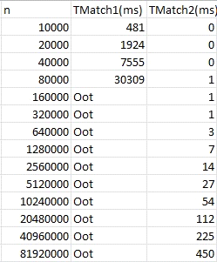

Computer Intel core i5-12600KF, 32 GB DDR5

It is appreciated that the main difference is in the table of the comparison of the 2 match functions, where match1 has a quadratic complexity, which means that times get really big with a low size. Here we can conclude that linear complexity is much better in terms of performance.

In match2, sum and maximum we can see how the linear complexity works as expected,

increasing as much as the number which the size is multiplied of, for example when the size is multiplied by 2, the times are also multiplied by 2.